Home page where you can see “flashing” upcoming events, Top bar where you see Saibaba photo is dynamic, you can change it any time, currently 5 photos are supported (we can photo of saibaba or our upcoming events)

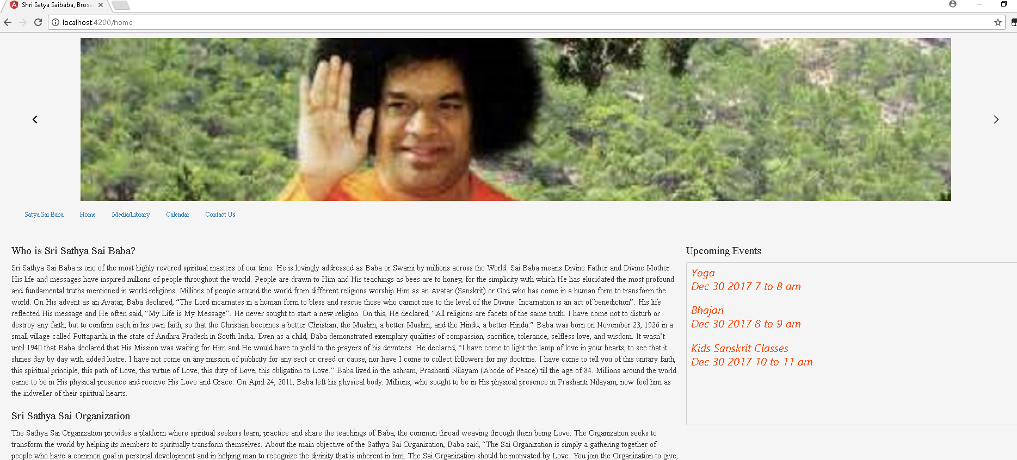

Whole medial libraries (videos, Audio and Text), there I gave youtube link because our videos are not private or controversial therefore we can upload them in youtube and it will be less expensive for us.

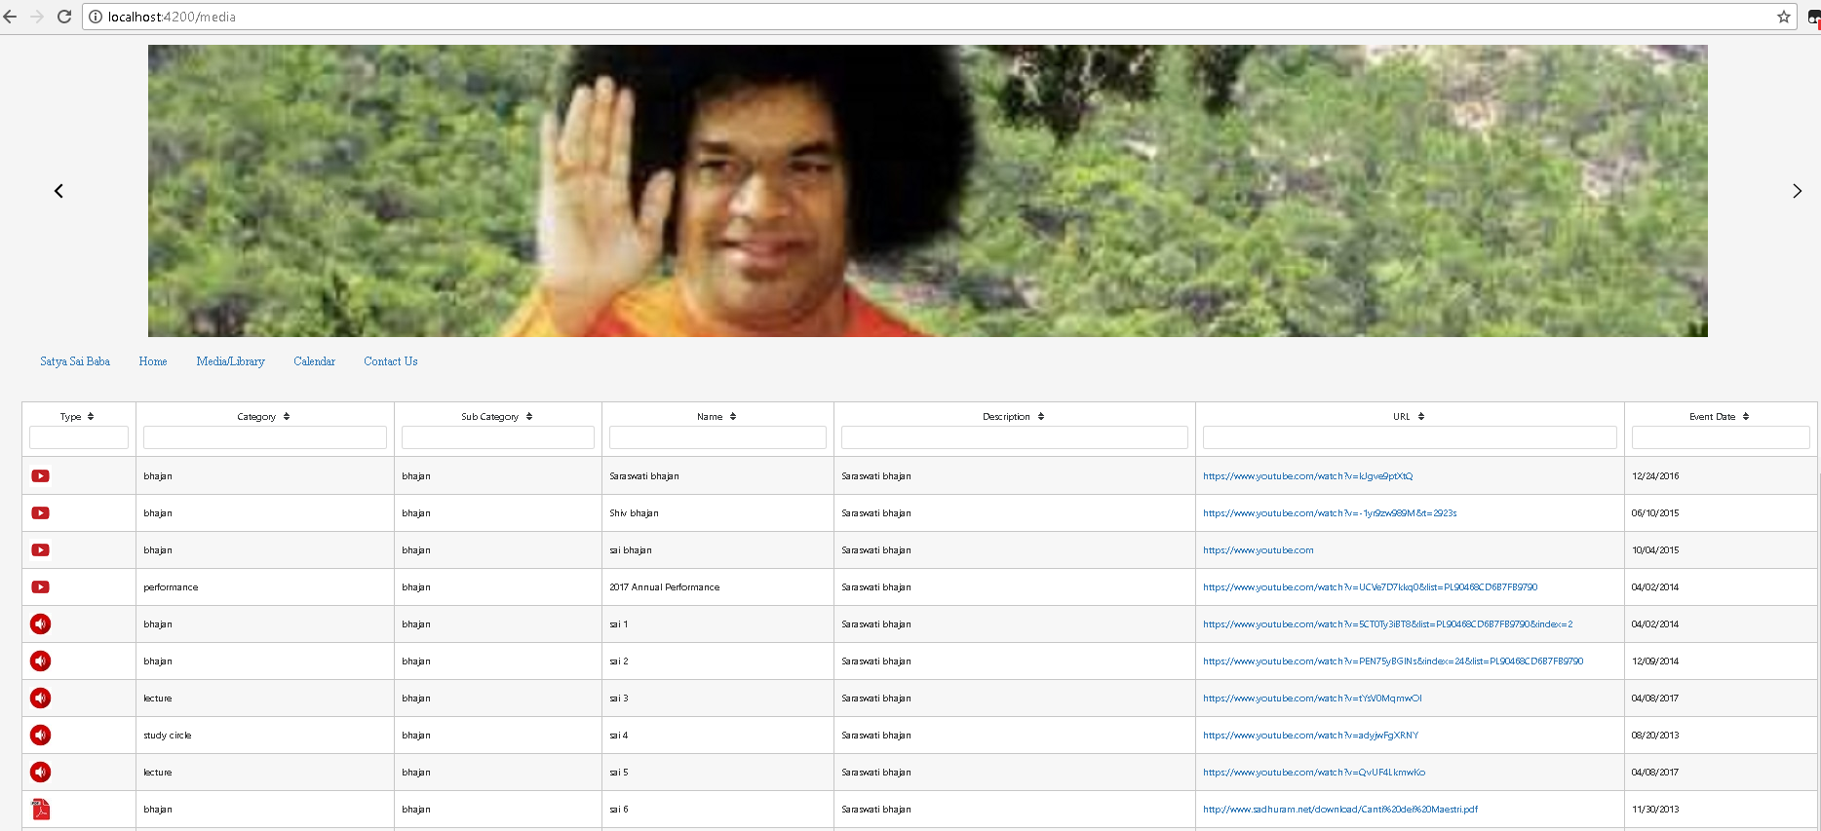

Here you can see full schedule of events like outlook. (you can have recorring event or one time event) for example you can see from morning 7 to 8 Yoga, 8-9 Bhajan and 10 to 11 Kids Sanskrit Classes.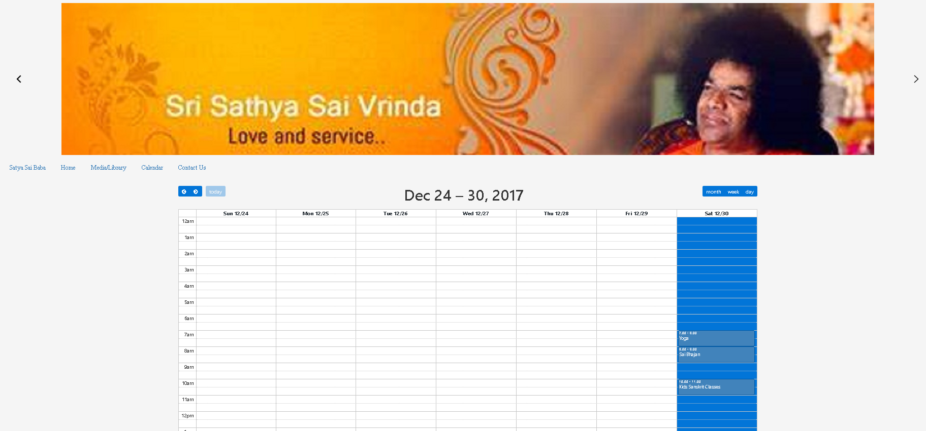

This is contact us screen, anybody can provide feedback or ask question to admin.

